SENG Model Parent Support Group Registration Form 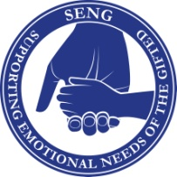
Last Name: First Name:
2nd adult
Email:
Phone Number(s):
Number of Children:
Age(s)/Grade(s):
Group Participation: I understand that all discussions/names of other participants and their children during SENG parenting sessions are to remain confidential. I understand that this is not a counselling group.
Please email your registration as soon as possible. Please mail a check or money order to 17416 32nd avenue, Surrey, V3S0L5. A week before class a message will be sent to you indicating the time and place for you to pick up your SENG book. A $25.00 service fee will be charged for all returned cheques.
I agree to the fee of $325.00, payable in advance. Receipts will be issued at the first session.
Please make cheques payable to: NP Educational Services or Niovi Patsicakis

Signature(s)________________________________________________________

